Barley Mow Primary

General Privacy Notice

This privacy notice has been written to inform individuals who come into contact with or visit Barley Mow Primary School about how and why we process your personal data. It includes when we process information relating to general queries, and complaints.

This privacy notice supplements the school’s other notices for pupils and parents, the workforce, and governors and volunteers.

Who are we?

Barley Mow Primary School is a data controller as defined by the UK GDPR. This means that we determine the purposes for which your personal data is processed and the manner of the processing. We will only collect and use your personal data in ways that are compliant with data protection legislation.

The school has appointed Veritau Ltd as its Data Protection Officer (DPO). The role of the DPO is to monitor our compliance with the UK GDPR and the Data Protection Act 2018 and advise on data protection issues. If you would like to discuss this privacy notice or our use of your data, please contact Veritau or the Head Teacher.

Veritau’s contact details are:

Schools Data Protection Officer
Veritau
West Offices
Station Rise
York
North Yorkshire
YO1 6GA
schoolsDPO@veritau.co.uk // 01904 554025

Please ensure you include the name of your school in all correspondence.
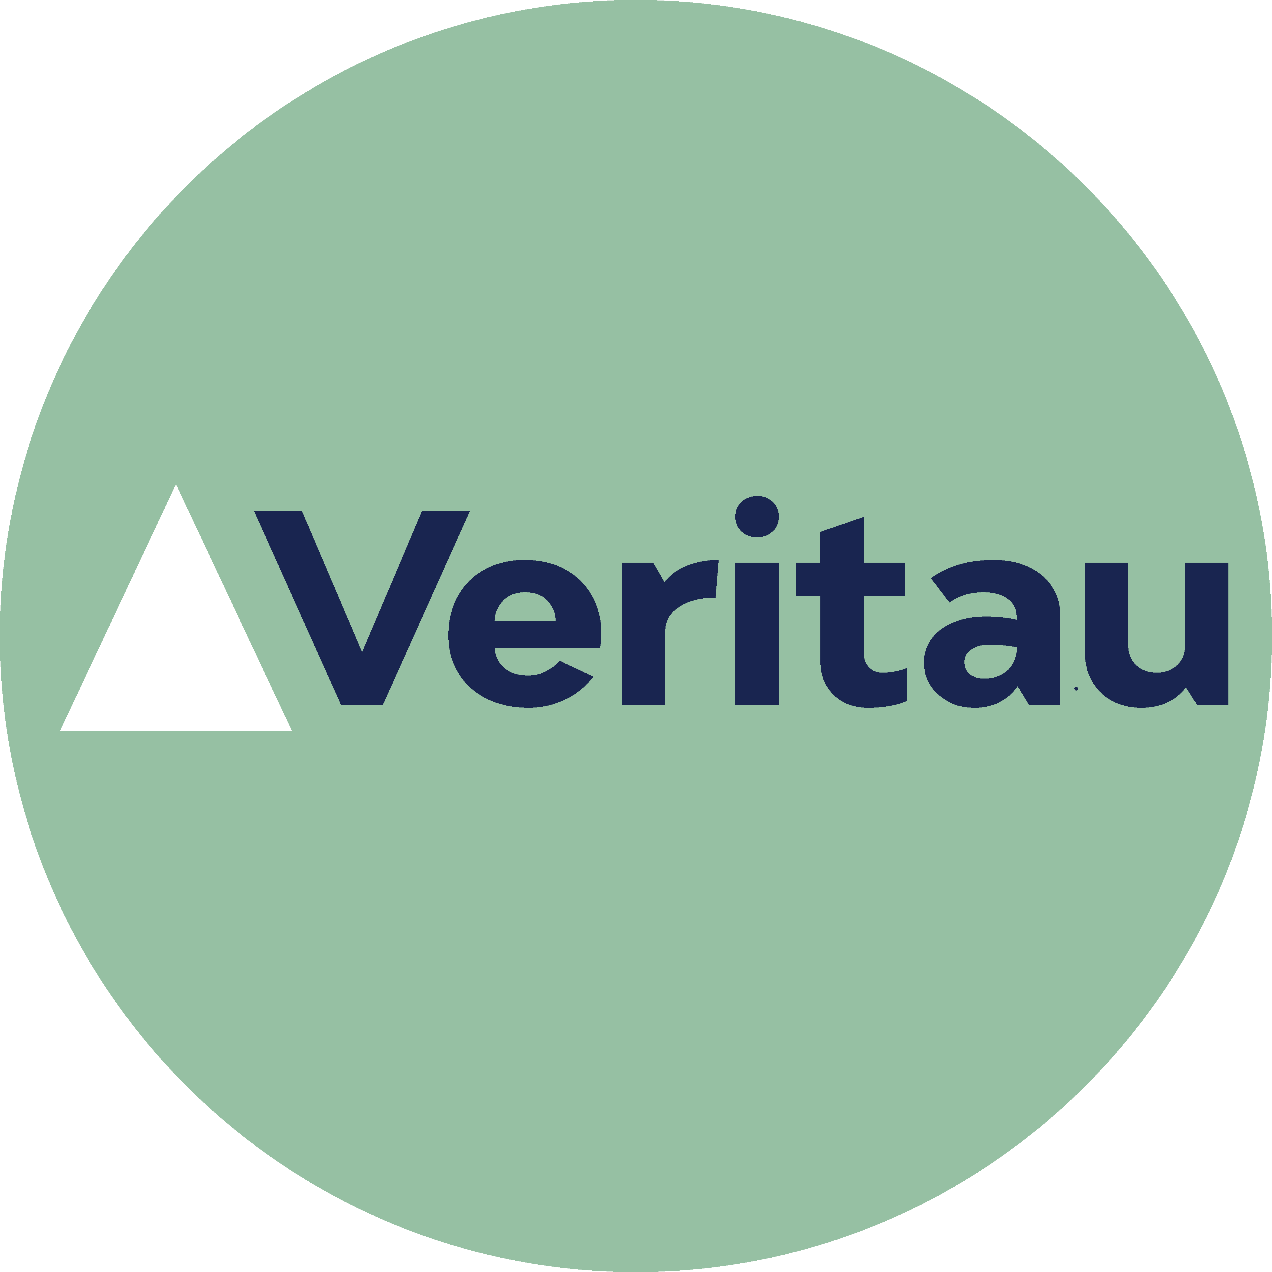

What personal information do we collect?

The personal data we collect about you will be dependent on the nature of your contact and relationship with us, but could include:

- Personal details, including name, address and contact information.
- Company details and contact information, if appropriate.
- Details of the reasons for contact with the school, and any communication preferences.
- Visitor information, such as the purpose of your visit and time you enter and leave the school, car registration number and any health conditions or disability access needs you tell us about.
- Photographs or video images, if you visit the school site or attend school events.
- Records of communications and interactions we have with you.
- Any details provided by yourself or third parties relating to a complaint investigation, including witness statements and interview notes.

Why do we collect your personal information?

We process your information for the purposes outlined below:

- To effectively respond to your query or request.
- To comply with a legal or regulatory obligation such as safeguarding and health and safety requirements.
- To process feedback and improve our services.
- To promote the school, including in newsletters, on the school website and social media platforms.
- To effectively administer the school’s complaints process.
- To monitor and inform our policies on equality and diversity.

What is our lawful basis for processing your information?

Under the UK GDPR, it is essential to have a lawful basis when processing personal information. We normally rely on the following lawful bases:

- Article 6(1)(a) – consent
- Article 6(1)(c) - legal obligation
- Article 6(1)(e) - public task

Where we are processing your personal data with your consent you have the right to withdraw that consent. If you change your mind or are unhappy with our use of your personal data, please let us know by contacting the Head Teacher.

There may be occasions where our processing is not covered by one of the legal bases above. In that case, we may rely on Article 6(1)(f) - legitimate interests. We only rely on legitimate interests when we are using your data in ways you would reasonably expect.

Some of the information we collect about you is classed as special category data under the UK GDPR. The additional conditions that allow for processing this data are:

- Article 9(2)(a) – explicit consent
- Article 9(2)(g) - reasons of substantial public interest

The applicable substantial public interest conditions in Schedule 1 of the Data Protection Act 2018 are:

- Condition 6 - statutory and government purposes
- Condition 18 - safeguarding of children and vulnerable people

Who do we obtain your information from?

We normally receive this information directly from you. However, we may also receive some information from the following third parties:

- Local Authority.
- Department for Education (DfE).
- A child’s previous school.
- Ofsted.
- Health and/or social care providers.
- Police and/or other law enforcement bodies.

Who do we share your personal data with?

We may share your information with the following organisations:

- Department for Education (DfE).
- Local Authority.
- Ofsted.
- Information Commissioner’s Office and/or Local Government Ombudsman.

We may also share information with other third parties where there is a lawful basis to do so. For example, we sometimes share information with the police for the purposes of crime detection or prevention.

How long do we keep your personal data for?

We will retain your information in accordance with our Records Management Policy and Retention Schedule. The retention period for most of the information we process about you is determined by statutory obligations. Any personal information which we are not required by law to retain will only be kept for as long as is reasonably necessary to fulfil its purpose.

We may also retain some information for historical and archiving purposes in accordance with our Records Management policy.

International transfers of data

Although we are based in the UK, some of the digital information we hold may be stored on computer servers located outside the UK. Some of the IT applications we use may also transfer data outside the UK.

Normally your information will not be transferred outside the European Economic Area, which is deemed to have adequate data protection standards by the UK government. In the event that your information is transferred outside the EEA, we will take reasonable steps to ensure your data is protected and appropriate safeguards are in place.

What rights do you have over your data?

Under the UK GDPR, individuals have the following rights in relation to the processing of their personal data:

- to be informed about how we process your personal data. This notice fulfils this obligation.
- to request a copy of the personal data we hold about you.
- to request that your personal data is amended if inaccurate or incomplete.
- to request that your personal data is erased where there is no compelling reason for its continued processing.
- to request that the processing of your personal data is restricted.
- to object to your personal data being processed.

If you have any concerns about the way we have handled your personal data or would like any further information, then please contact our DPO using the details provided above.

If we cannot resolve your concerns then you may also complain to the Information Commissioner’s Office, which is the UK’s data protection regulator. Their contact details are below:

Phone: 0303 123 1113 or via their live chat. Opening hours are Monday to Friday between 9am and 5pm (excluding bank holidays). You can also report, enquire, register and raise complaints with the ICO using their web form on Contact us | ICO.

Changes to this notice

We reserve the right to change this privacy notice at any time. We will normally notify you of changes that affect you. However, please check regularly to ensure you have the latest version.

This privacy notice was last reviewed September 2024.

