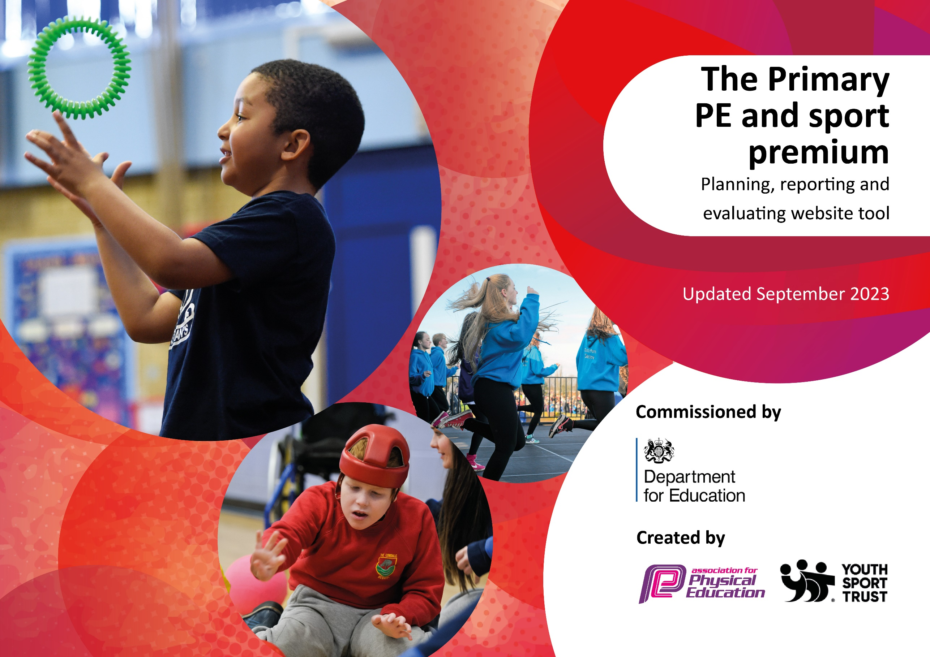

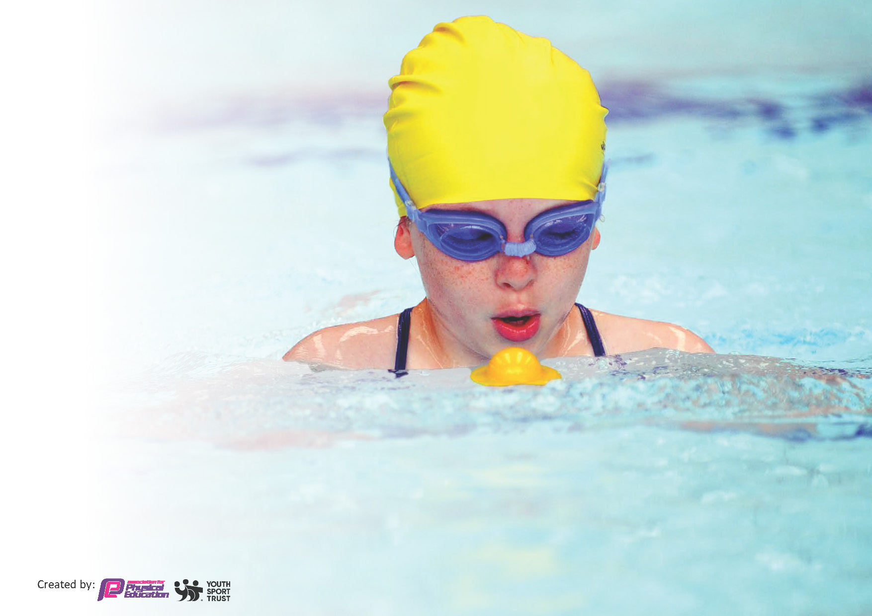
This template can be used for multiple purposes:
by:
- It enables schools to effectively plan their use of the Primary PE and sport premium
- It helps schools to meet the requirements (as set out in guidance) to publish information on their Primary PE and sport premium
- It will be an effective document to support Ofsted inspections enabling schools to evidence progress in Physical Education (PE) and evidence swimming attainment, which forms part of the PE National Curriculum. We would recommend schools consider
the Intent, Implementation and Impact of any spend, as examined within the Education Inspection Framework.

It is important that your grant is used effectively and based on school need.

Schools must use the funding to make additional and sustainable
improvements to the quality of the PE, School Sport and Physical Activity (PESSPA)
they offer. This means that you should use the Primary PE and sport premium to:

- Build capacity and capability within the school to ensure that improvements made now will benefit pupils joining the school in future years
- Develop or add to the PESSPA activities that your school already offers.

The Primary PE and sport premium should not be used to fund capital spend projects; the school’s core budget should fund these. Further detail on capital expenditure can be found in the updated Primary PE and sport premium guidance.

The Primary PE and sport premium guidance, outlines 5 key priorities that funding should be used towards. It is not

necessary that spending has to meet all the key priorities, you should select the priorities that you aim to use any funding towards.

Although completing this template is not a requirement for schools, schools are required to publish details of how they spend this funding. Schools must also outline what the impact this funding has had on pupils’ PE and sport participation and attainment and how any spending will be sustainable in the future. All funding must be spent by 31st July 2024.

The Department for Education has worked closely with the Association for Physical Education (afPE) and the Youth Sport Trust (YST) to develop this template and encourages schools to use it. This template is an effective way of meeting the reporting requirements of the Primary PE and sport premium.
Review of last year’s spend and key achievements (2022/2023)

We recommend you start by reflecting on the impact of current provision and reviewing your previous spend.

Activity/Action | Impact | Comments
Raising the profile of PE in school. This year the school is continuing to access ‘Get Set 4 PE.’  School has bought into School Sport’s Partnership Gateshead.  The school buys into the Newcastle United Foundation in which | This allows staff to choose their proposed unit and receive access to lesson plans and resource ideas.  This has meant a free coach is received for a half term as well as half a day’s CPD which can be used to address aspects of PE deemed appropriate for school. CPD opportunities are also available throughout the academic year for the PE lead and staff.  They provide coach-led sessions throughout the academic year for year groups from Y1-6. They also provide a weekly club which was mapped out by the PE lead and sent to the NUF to plan and deliver. | Monitor the next academic year to ensure use of ‘GetSet4PE’ is continuing to be useful.  Purchase again ensuring another year group benefit from the free coaching sessions and CPD differs from previous years to widen subject knowledge for staff.  Purchase again and discuss what was effective and what may be changed for this academic year. Encourage teaching of sports with the aim of inter competitions to apply skills and develop competition participation and familiarity.

Key priorities and Planning
This planning template will allow schools to accurately plan their spending.

Action – what are you planning to do | Who does this action impact? | Key indicator to meet | Impacts and how sustainability will be achieved? | Cost linked to the action
Affiliation to Gateshead School Sports Partnership Premium Membership and Schools Health and Wellbeing SLA  PE scheme subscription  Coaching  - Dance Coach  - Little Movers Coach  - NUF Coach  - GSSP Half term sports coach included in membership  PE and OPAL equipment and uniform  Support staff to allow children to access OPAL equipment successfully.  Support staff to allow children to attend PE events.  Transport to events/competitions | - PE lead/coordinator  - School Staff  - Children  - Access for teaching staff  - Consistency of structured PE lessons for children where skills are built upon.  - Staff CPD  - Children  - Teaching Staff  - Children  - Lunchtime supervisors  - Children  - Children  - Children | Key Indictor 1 – Increased confidence, knowledge, and skills of all staff in teaching PE and sport.  Key Indicator 2 – Engagement of all pupils in regular physical activity.  Key indicator 3 – The profile of PE and sport raised across the school as a tool for whole school improvement.  Key indicator 4 – Broader experience of a range of sports and activities offered to all pupils.  Key indicator 5 – Increased participation in competitive sport.  Key Indictor 1 – Increased confidence, knowledge, and skills of all staff in teaching PE and sport.  Key Indicator 2 – Engagement of all pupils in regular physical activity.  Key Indictor 1 – Increased confidence, knowledge, and skills of all staff in teaching PE and sport.  Key Indicator 2 – Engagement of all pupils in regular physical activity.  Key indicator 3 – The profile of PE and sport raised across the school as a tool for whole school improvement.  Key indicator 4 – Broader experience of a range of sports and activities offered to all pupils.  Key indicator 5 – Increased participation in competitive sport.  Key Indictor 1 – Increased confidence, knowledge, and skills of all staff in teaching PE and sport.  Key Indicator 2 – Engagement of all pupils in regular physical activity.  Key indicator 4 – Broader experience of a range of sports and activities offered to all pupils.  Key Indicator 2 – Engagement of all pupils in regular physical activity.  Key indicator 3 – The profile of PE and sport raised across the school as a tool for whole school improvement.  Key indicator 4 – Broader experience of a range of sports and activities offered to all pupils.  Key indicator 5 – Increased participation in competitive sport.  Key Indicator 2 – Engagement of all pupils in regular physical activity.  Key indicator 4 – Broader experience of a range of sports and activities offered to all pupils.  Key indicator 5 – Increased participation in competitive sport. | Access and opportunities for children to attend intra-school competitions and activity days. There is cluster support included in the form of events, coaching days, workshops, and conference opportunities.  Providing support for teachers with their planning and delivery of PE lessons. The subscription ensures that all skills (age appropriate) are being taught as clear progression can be mapped out.  As a school it is vital, we promote the importance of PE to our children and help children create a love for exercise. Lessons led by coaches allow for a range of adaptable skills to be taught and as a result help to prepare for competitions linked to these skills and sports.  Staff confidence can be enhanced when teaching PE lessons with the correct equipment. It can also enhance the children’s understanding of a particular sport as it can be demonstrated and carried out accurately when using the correct equipment. OPAL equipment enhances lunchtimes allowing more opportunity for active learning.  Children will begin to identify why exercise is important to complete daily. This enables children the opportunity to try a range of sports to complete their 60 active minutes daily.  Enables children to gain experience alongside other children their age to apply taught skills by participating in events.  Enables children to take part in inter-competitions where they can apply taught skills alongside peers their own age. | £3275  £550  CDC Dance-£1600.50  Little Movers-£300  NUF-£3350  GSSP Coach-Provided as part of paid package  £2000  £2000  £2000  £2000

Key achievements 2023-2024
This template will be completed at the end of the academic year and will showcase the key achievements schools have made with their Primary PE and sport premium spending.

Activity/Action | Impact | Comments
Affiliation to Gateshead School Sports Partnership Premium Membership and Schools Health and Wellbeing SLA  PE scheme subscription  Coaching  - Dance Coach  - Little Movers Coach  - NUF Coach  - GSSP Half term sports coach included in membership  PE and OPAL equipment and uniform  Support staff to allow children to access OPAL equipment successfully.  Support staff to allow children to attend PE events.  Transport to events/competitions | Allows PE lead to gain vital CPD to lead the subject. Gives children the opportunity to attend a range of events when suitable.  Supports teachers to deliver progressive lessons which cover all skills needed in each PE unit.  Coaches give CPD to staff to gain knowledge for future teaching and applying what they have learned to their own lessons. Provides children with lessons lead by staff who can demonstrate skills and apply these to units of work.  A range of equipment provided allows children to access a range of skills during break times, lunch times and PE lessons. This can support their developing skills and encourages exposure to skills which may need further practice.  Staff can direct children to use equipment to support their ability in a physical activity. They can also encourage children to try a range of activities which may not be accessed as frequently elsewhere.  Staff being available provides further opportunity for children to experience events in which they can apply learned skills and interact with other children from other schools either a competitive way or team way.  Transport allows children the opportunities to attend events to gain further experience with other schools developing skills learned. | Continue with this for new subject lead.  Subscribe again to continue to develop skills and ways to adapt lessons to suit a range of abilities.  Staff to use this time to continue to develop their own skills and adapt their teaching of PE to support learned skills and how to apply these in a game setting.  Audit equipment and ensure any equipment requested this year that could not be purchased can be priority for the upcoming year e.g. small hoops, bean bags, tennis balls.  Further training for staff to expand range of knowledge and ways children can be more active. This has been used to engage children during lunchtimes however could be expanded further if there was staff capacity.  There has been a good range of activities taking place at Lord Lawson which has allowed children to experience Sports in a different environment alongside other schools. Some events were accessed at different venues but could expand to all year groups if events are relevant and staffing available at that time.  Children have been able to participate in events which have allowed them to engage with other schools and showcase skills they have learned in their PE lessons. Possibly share coaches with nearby schools to help reduce costs and attend more events.

Swimming Data
Meeting National Curriculum requirements for swimming and water safety.
Priority should always be given to ensuring that pupils can perform safe self-rescue even if they do not fully meet the first two requirements of the National Curriculum programme of study

Question | Stats: | Further context  Relative to local challenges
What percentage of your current Year 6 cohort can swim competently, confidently and proficiently over a distance of at least 25 metres? | 67%
What percentage of your current Year 6 cohort can use a range of strokes effectively [for example, front crawl, backstroke, and breaststroke]? | 28%

What percentage of your current Year 6 cohort are able to perform safe self-rescue in different water-based situations? | 83%
If your schools swimming data is below national expectation, you can choose to use the Primary PE and sport premium to provide additional top-up sessions for those pupils that did not meet National Curriculum  requirements after the completion of core lessons. Have you done this? | No
Have you provided CPD to improve the knowledge and confidence of staff to be able to teach swimming and water safety? | No

Signed off by:

Head Teacher: | N.Watson
Subject Leader or the individual responsible for the Primary PE and sport premium: | H.Coxon-PE lead
Governor: | M.Martin
Date: | 11.7.24

