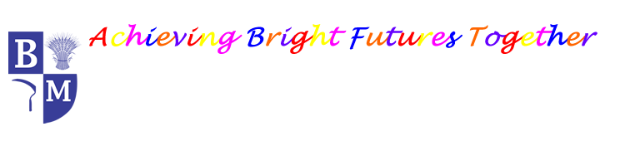
Barley Mow Primary School
MFL Long Term Plan (Revised July 2023)

 | Autumn Term | Spring Term | Summer Term | Summer Term
Y3 | Phonetics Lessons 1 (C)  J'apprends le français  (I Am Learning French) (E) | Les animaux  (Animals)  (E) | Les instruments (Instruments)  (E) | Je peux  (I am able..) (E)
Y4 | Phonetics Lesson 2 (C)  Je me présente (Presenting Myself) (I) | Ma famille  (My Family) (I) | En classe  (In the Classroom) (I) | Au salon de thé  (At the Tea Room) (I)
Y5 | Phonics Lesson 3 (C)  As-tu un animal ? (Do You Have a Pet?) (I) | La date (The Date) (I) | Les vêtements  (Clothes) (I)
Y6 | Phonetics Lesson 4 (C)  À l'école (At School) (P) | Manger et Bouger (Healthy Lifestyles) (P) | Le week-end  (The Weekend) (P)

