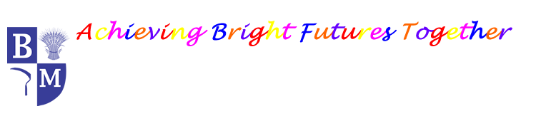
Barley Mow Primary School
History Long Term Plan
 | Autumn  Term | Spring  Term | Summer  Term
EYFS | Family History | / | Kings and Queens
EYFS | Ongoing through understanding our world, daily routines and speaking and listening
Year 1 | Childhood Now and Then  What was life like for our grandparents(and great grandparents) when they were children? | Castles  What was life like in a medieval castle? | Beside the Seaside  How have holidays changed over time?  Why do we remember Grace Darling?
Year 2 | Great Fire of London  What changed because of the Great Fire of London and Gateshead? | Travel and Transport  How did George Stephenson change transport? | Medical Heroes  Why should we remember Florence Nightingale and Mary Seacole?
Year 3 | Stone Age to Bronze Age  What changed from the Stone Age to the Iron Age? | Birtley Belgians  Why do we remember the Birtley Belgians? | Romans  What legacy have the Romans left?
Year 4 | Egyptians  How have people been able to learn about the Ancient Egyptians? | WWII  What was the impact of the Second World War on the people of Britain? | Mayans  Why do we remember Maya?
Year 5 | Anglo-Saxons  Who were the Anglo Saxons and how did they change Britain? | Vikings  What is the legacy of the Vikings? | Ancient Greece  What did the Ancient Greeks do for us?
Year 6 | Victorians  How did the Industrial Revolution change Britain? | The Suffragette Movement  What was the impact of the suffragette movement? | The Changing Power of Monarchs  How has the monarchy changed over time?

