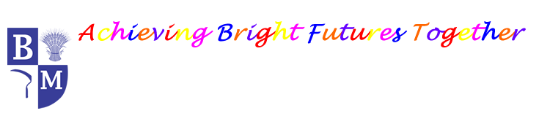
Barley Mow Primary School
PSHE Long Term Plan
 | Autumn Term |  | Spring Term |  | Summer Term
EYFS | MY World and I | Celebrations and Magic | Traditional Tales | I Wonder… | Nature explorers | Out and about – Our Journey
EYFS | Ongoing through Personal, Social and Emotional Development.
Year 1 | Families and relationships  Health and wellbeing |  | Health and wellbeing  Safety and the changing body |  | Citizenship  Economic wellbeing
Year 2 | Families and relationships  Health and wellbeing |  | Health and wellbeing  Safety and the changing body |  | Citizenship  Economic wellbeing
Year 3 | Families and relationships  Health and wellbeing |  | Health and wellbeing  Safety and the changing body |  | Citizenship  Economic wellbeing
Year 4 | Families and relationships  Health and wellbeing |  | Health and wellbeing  Safety and the changing body |  | Citizenship  Economic wellbeing
Year 5 | Families and relationships  Health and wellbeing |  | Health and wellbeing  Safety and the changing body |  | Citizenship  Economic wellbeing
Year 6 | Families and relationships  Health and wellbeing |  | Health and wellbeing  Safety and the changing body |  | Citizenship  Economic wellbeing  Identity

