
Barley Mow Primary School
PSHE Policy
Introduction
This policy outlines the teaching, organisation and management of PSHE education taught and learnt at Barley Mow Primary school. It reflects the school’s values and ethos.

Definition of PSHE
Personal, Social, Health and Economic (PSHE) education encompasses all areas designed to promote children’s personal, social, health and economic development. It gives children the knowledge, skills and attributes that they need to stay healthy and safe, develop worthwhile relationships, respect differences, develop independence and responsibility, and make the most of their own abilities and those of others.

Statement of Intent
At Barley Mow Primary, our intent for PSHE is to provide opportunities for children to develop in a well- balanced way beyond the academic; to move from childhood to adolescence with support and guidance, encouraging both an awareness of others and the growth of responsible independence. We will explore our own beliefs, experiences, values, principles, moral and ethical views, celebrate them and accept those from different countries, religions and cultures. Through this, our children can develop confidence, talents and skills to become effective individuals, motivated learners and active citizens. We want to prepare them for the future by encouraging the development of characteristics for life such as a love of learning, resilience, integrity, team work, critical thinking and independence. We want to prepare them for the world of work and support them in developing enterprise skills and financial awareness.
Our PSHE curriculum covers the RSE and Health Education statutory guidance (as set out by the Department of Education) as follows:

Through relationship education we aim to ensure that all pupils:
- Understand the relationships within families and between people who care for them.
- Exploring characteristics of healthy family life, commitment to each other, protection and care for children and other family members, the importance of spending time together and sharing each other’s lives.
- Understand the importance of friendship, including mutual respect, trustworthiness, loyalty, trust, sharing experiences and interests and support with problems and difficulties.
- Understand the importance of respectful relationships, respecting others even when they are very different from them (e.g. physically, in character, personality or background).
- Recognise the importance of self- respect and how this links to happiness.
- Understand that the same principles apply to online relationships as to face- to -face relationships.
- Have the skills and knowledge to stay safe, exploring boundaries, privacy, appropriateness and how to ask for help and advice.
Through physical health and mental wellbeing education we aim to ensure that all pupils:
- Understand that mental wellbeing is a normal part of daily life, in the same way as physical health.
- Consider the effect of their own and others online actions and know how to recognise and display respectful behaviour online.
- Recognise the characteristics of mental and physical benefits of an active lifestyle.
- Recognise what constitutes a healthy diet.
- Have knowledge and facts about legal and illegal harmful substances and associated risks, including smoking, alcohol use and drug use.
- Understand and have knowledge about physical illness, sun exposure, sleep, dental health, personal hygiene and puberty.

Curriculum
At Barley Mow Primary School, we teach using a whole school approach for PSHE from nursery to Year 6, based on the Kapow scheme of work. The Kapow Primary scheme provides full curriculum coverage, including all the statutory content for each year group. It is linked to the Ofsted Framework and incorporates Government guidance on British Values and SMSC. It links to the school Safeguarding, RSE, Mental Health and Equality policies.

Early Years
In the Early Years Foundation Stage, PSHE is referred to as personal, social and emotional development. The curriculum follows Birth to 5 Matters and the EYFS Principles. Resources from the Kapow Primary scheme are adapted and used appropriately to the children.
Personal, Social and Emotional development is at the heart of the Early Years curriculum. It is an integral part of the curriculum implemented through planned, purposeful play and through a mix of adult-led and child-initiated activities. Children engage in activities individually, as part of a small group or in whole class situations, helping to develop a positive sense of themselves, and others; to form positive relationships and develop respect for others; to develop social skills and learn how to manage their feelings; to understand appropriate behaviour in groups; and to have confidence in their own abilities.
See appendix 1 for EYFS long term planning documents for Personal, Social and Emotional development.

Key Stage 1 and Key Stage 2
The Kapow Primary scheme has five areas of learning across Key Stages 1 and 2. Each are is revisited to allow children to build on prior knowledge. These areas are:
● Families and relationships
● Health and wellbeing
● Safety and the changing body
● Citizenship
● Economic wellbeing
See appendix 2 for mapping of the coverage of the statutory Relationships Education, Relationships and Sex Education (RSE) and Health Education published by the Department for Education.

Key Stage 1
During Key Stage 1, pupils learn about themselves as individuals and as members of the community. They learn to recognise similarities and differences between themselves and others. They learn what a relationship is, what friendship is, what family means and who the people are who can support them. They begin to learn about their own and other people’s feelings and develop awareness of their views, needs and rights of other children and adults. Building on their early education, pupils develop social skills such as how to share, take turns, play, help others, resolve simple arguments and understand the difference between appropriate and inappropriate or unsafe physical, and other, contact. They learn basic rules and skills for keeping themselves healthy and safe and the people who help us to do these things and how to seek help. They develop awareness of the world around us in relation to jobs that people do, how money is earned and used, the role of the internet and simple ways they can take responsibility for themselves and the environment.

KS 1 curriculum content overview
 | Year 1 | Year 2
Families and relationships | • Introduction to RSE  • What is family?  • What are friendships?  • Family and friends help and support each other  • Making friends  • Friendship problems  • Healthy Friendships | • Introduction to RSE  • Families offer stability and love  • Families are all different  • Managing friendships  • Unhappy friendships  • Valuing me  • Manners & courtesy  • Loss and change
Health and wellbeing | • Getting lost  • Making a call to the emergency services  • Asking for help  • Appropriate contact  • Medication  • Safety at home  • People who help to keep us safe | • The Internet  • Communicating online  • Secrets and surprises  • Appropriate contact  • Road safety  • Drug education
Safety and the changing body | • Wonderful me  • What am I like?  • Ready for bed  • Relaxation  • Hand washing & personal hygiene  • Sun safety  • Allergies  • People who help us stay healthy | • Experiencing different emotions  • Being active  • Relaxation  • Steps to success  • Growth mindset  • Healthy diet  • Dental health
Citizenship | Responsibility  • Rules  • Caring for others: Animals  • The needs of others  Community  • Similar, yet different  • Belonging  Democracy  • Democratic decisions | Responsibility  • Rules beyond school  • Our school environment  • Our local environment  Community  • Job roles in our local community  • Similar yet different: My local community  Democracy  • School Council  • Giving my opinion
Economic wellbeing | Money  • Introduction to money  • Looking after money  • Banks and building societies  • Saving and spending  Career and aspirations  • Jobs in school | Money  • Where money comes from  • Needs and wants  • Wants and needs  • Looking after money  Career and aspirations  • Jobs

Key Stage 2
During Key Stage 2, children learn about the fundamental building blocks and characteristics of positive relationships, with particular reference to friendships, family relationships, and relationships with other children and adults. They learn about themselves as growing and changing individuals with their own experiences and ideas, and as members of their communities. As they begin to develop into young adults, they face the changes of puberty and transfer to secondary school with support and guidance from school. They learn the importance of treating each other with kindness, consideration and respect, the importance of honesty and truthfulness, permission seeking and giving, and the concept of personal privacy. They develop understanding of personal space and boundaries, showing respect and understanding the differences between appropriate and inappropriate or unsafe physical, and other, contact and where and how to seek help. They learn how to make more informed choices and the steps they can take to protect and support their own and others’ health and wellbeing, including simple self-care techniques, personal hygiene, prevention of health and wellbeing problems and basic first aid. Learning takes place regarding feelings and experiences including isolation, loneliness, unhappiness, bullying (including online) and the negative impact of poor health and wellbeing. They learn where and how to seek help in these situations. They learn about the wider world and the interdependence of communities within it. They develop their sense of social justice and moral responsibility and begin to understand that their own choices and behaviour can affect local, national or global issues and political and social institutions. They consider their aspirations for their future; the decisions they make and their career path. Children develop their media literacy and digital resilience and become equipped to manage common difficulties encountered online.
KS 2 curriculum content overview
 | Year 3 | Year 4 | Year 5 | Year 6
Families and relationships | • Introduction to RSE  • Healthy families  • Friendships - conflict  • Effective communication  • Learning who to trust  • Respecting differences  • Stereotyping | • Introduction to RSE  • Respect & manners  • Healthy friendships  • My behaviour  • Bullying  • Stereotypes  • Families in the wider world  • Loss and change | • Introduction to RSE  • Build a friend  • Resolving conflict  • Respecting myself  • Family life  • Bullying | • Introduction to RSE  • Respect  • Developing respectful relationships  • Stereotypes  • Bullying  • Being me  • Loss and change
Health and wellbeing | • Basic first aid  • Communicating safely online  • Online safety  • Fake emails  • Drugs, alcohol & tobacco  • Keeping safe out and about | • Online restrictions  • Share aware  • Basic first aid  • Privacy and secrecy  • Consuming information online  • The changing adolescent body (puberty) | • Online friendships  • Identifying online dangers  • The changing adolescent body (puberty, including menstruation)  • First aid  • Drug education | • Drugs alcohol & tobacco  • First aid  • Critical digital consumers  • Social media  • The changing adolescent body (puberty, conception, birth)
Safety and the changing body | • My healthy diary • Relaxation  • Who am I?  • My superpowers  • Breaking down barriers  • Dental health | • Diet and dental health  • Visualisation  • Celebrating mistakes  • My role  • My happiness  • Emotions  • Mental health | • Relaxation  • The importance of rest  • Embracing failure  • Going for goals  • Taking responsibility for my feelings  • Healthy meals  • Sun safety | • What can I be?  Mindfulness  • Taking responsibility for my health  • Resilience toolkit  • Immunisation  • Health concerns  • Creating habits  • The effects of technology on health
Citizenship | Responsibility  • Rights of the child  • Rights and responsibilities  • Recycling  Community  • Local community groups  • Charity  Democracy  • Local democracy  • Rules | Responsibility  • What are human rights?  • Caring for the environment Community  • Community groups  • Contributing  • Diverse communities Democracy  • Local councillors | Responsibility  • Breaking the law  • Rights and responsibilities  • Protecting the planet  Community  • Contributing to the community  • Pressure groups Democracy  • Parliament | Responsibility  • Human rights  • Food choices and the environment  • Caring for others Community  • Prejudice and discrimination  • Valuing diversity Democracy  • National democracy
Economic wellbeing | Money  • Ways of paying  • Budgeting  • How spending affects others  • Impact of spending  Career and aspirations  • Jobs and careers  • Gender and careers | Money  • Spending choices/ value for money  • Keeping track of money  • Looking after money  Career and aspirations  • Influences on career choices  • Jobs for me | Money  • Borrowing  • Income and expenditure  • Risks with money  • Prioritising spending  Career and aspirations  • Stereotypes in the workplace | Money  • Attitudes to money  • Keeping money safe  • Gambling  Career and aspirations  • What jobs are available  • Career routes
Identity |  |  |  | • What is identity  • Identity and body image

Teaching and Learning
We teach PSHE Education to all children at Barley Mow Primary School. The work carried out in these sessions will be drawn from objectives taken from our whole-school curriculum overview for PSHE, or in response to a specific identified need within the class (e.g. managing issues around forming relationships; addressing behaviour etc). The Kapow Primary scheme is used to support planning and delivery of PSHE lessons and covers the five main areas; Families and Relationships, Health and Wellbeing, Safety and the Changing Body. Citizenship and Economic Wellbeing.
Teachers provide learning opportunities that are matched to the individual needs of all children including those with learning difficulties. We use a range of teaching and learning approaches including:
- Establishing clear ground rules in consultation with children. Ground rules include confidentiality, respect for others, privacy and boundaries.
- Using distancing techniques including de-personalised discussions and role play.
- Using clear language to avoid misunderstandings.
- Avoiding prejudice and assumptions about children’s abilities, desires, background and experiences.
- Dealing sensitively with unexpected questions and comments.
- Assessing and building on existing knowledge and experiences.
- Ensuring that learning is engaging, using a range of activities, including structured discussion and problem-solving.
- Providing a range of opportunities to learn, practise and demonstrate knowledge, skills and attitudes.
- Allowing time for reflection.
- Providing adapted learning.
- Using a variety of groupings to enhance learning.

As they move through school we encourage children to take part in a range of practical activities that promote British Values and promote SMSC development. For example: Anti-Bullying Week, Safer Internet Day, charity fundraising and class assemblies. Many of these opportunities are delivered through a whole-school approach.

Contribution of PSHE in Teaching of the Wider Curriculum
PSHE education covers a range of topics, including many pressing issues facing children today including mental health, staying safe online, positive relationships, drugs, alcohol, challenging stereotypes, the role of the media, their future contribution to the workforce and financial literacy. The subject aims to have a positive impact on a number of outcomes for young people, including their physical and mental health, safety, careers, financial capability and economic wellbeing. It follows, then, that PSHE impacts positively on all aspects of curriculum learning, both implicitly and explicitly. Opportunities for cross-curricular learning can be derived explicitly in science (living a healthy lifestyle), computing (safety), mathematics (money management) and literacy (e.g. stories with moral dilemmas).

Opportunities for Engagement and Enrichment
Visitors to the classroom enrich our PSHE teaching and learning by providing expert knowledge or accounts of personal experiences. Visitors are valuable resources to enable learning and their inputs are always planned for and relevant. The teacher is always present to manage the learning and there is both learning prior to the visit and as follow-up to the visit. For example, in Early Years, visits by the police, the fire and rescue service and dental nurses help to develop children’s understanding of ‘People who Help Us.’ In Upper Key Stage 2, school nurses deliver learning on puberty. Trained NSPCC volunteers deliver the ‘Speak out Stay safe’ programme workshops.
Our School Pledge outlines a range of enrichment activities which relate to British Values and SMSC development.

Inclusion
Throughout their school career, children will be at different levels of maturity, will have varied life experiences and a range of attitudes and feelings. Lessons should be planned to allow their perceptions to be articulated, with all contributions being valued and respected. In relation to some sensitive issues, such as RSE or drug education, the teacher needs to ensure that the teaching point is conveyed in language that is accessible and appropriate to the children.
Teachers may need to use different resources, activities or provide specific support depending on the needs of their pupils. The learning opportunities should be broad and balanced and provide for pupils’ different learning styles.

Impact
Children will develop a clear knowledge of all aspects of PSHE curriculum. PSHE offers both explicit and implicit learning opportunities and experiences which reflect pupils’ increasing independence and physical and social awareness, as they move through the primary phase. Through high quality teaching, the skills that pupils started to acquire during the Early Years Foundation stage (EYFS) are built upon to develop effective relationships, assume greater personal responsibility and manage personal safety, including online. PSHE education helps pupils to manage the physical and emotional changes at puberty, introduces them to a wider world and enables them to make an active contribution to their communities.

Monitoring and Evaluation
The PSHE Subject Leader and Senior Management Team are responsible for the monitoring and evaluation of:
- Curriculum coverage
- The quality of teaching and learning
- Standards of achievement

This will be carried out through:
- Evaluation of medium and short term planning
- Scrutiny of work samples
- Noting and tracking children against expectations
- Observation of classroom practice in line with school policy
- Learning Walks
- Pupil Conferencing

The Role of the Subject Leader:
It is the responsibility of the PSHE Leader:
- To take a lead in policy development
- To support colleagues in their teaching of PSHE content and developing subject knowledge
- To identify the need for individual support in the form of CPD
- To create, maintain and evaluate action plans and audits
- To take steps to keep up with developments and inform colleagues as appropriate

Teacher’s Role

Each class teacher is responsible for the day to day implementation of the PSHE Policy within their own classroom. Responsibilities include:
- Planning effectively for PSHE lessons in termly and weekly plans
- To ensure progression of PSHE skills
- To develop and update skills, knowledge and understanding of PSHE
- To identify what resources are needed for lessons and liaise with subject Leader to purchase if necessary.

Support and advice will be available, when appropriate, from the PSHE Leader.

Resources
Staff access resources for the Kapow Scheme through the Kapow website. Some resources are held centrally and some are held by individual teachers and the PSHE Leader. All resources are reviewed annually.

ICT
ICT will be used in various ways to support teaching and motivate pupils’ learning. ICT involves the computer, and audio-visual aids, DVDs’ and various software. The school’s set of laptops and I-pads may be used to enhance lessons and enable children to find information off the internet and other programs to support their learning such as archive collections.

Assessment
In the Early Years Foundation Stage, practitioners use their judgement to assess children to decide whether they have met each Early Learning Goal or whether their level of attainment is above or below that described in the Early Learning Goal.
Each unit taught in KS1 and KS2 will be assessed using methods selected by the teacher as the most appropriate way to assess what children have learnt. This may be achieved through:
- Use of Kapow end of unit tests
- Questioning
- Observing
- Discussion
- Mind maps
- Regular quizzes to ensure retention of knowledge.
- Written task
Teachers will use regular formative assessment to inform future planning, to ensure progress and to address misconceptions. These regular assessments will support teachers in their final judgement at the end of the year. End of year assessments will be completed and stored in the assessment folder in resources to enable the PSHE Leader and members of the SLT to monitor standards.

Conclusion
A review of the policy for PSHE will take place as necessary in accordance with the school review process. Should changes need to be made in the interim as part of a curriculum review process or changes to statutory orders, an amendment will be made to this document in the form of an appendix.

Policy reviewed- May 2023
Policy to be reviewed – May 2025

Appendix 1
EYFS Long term plans for Personal, social and Emotional Development

Appendix 2
Mapping of the coverage of the statutory Relationships Education, Relationships and Sex Education (RSE) and Health Education published by the Department for Education.

Appendix 1
EYFS Long term plans for Personal, social and Emotional Development

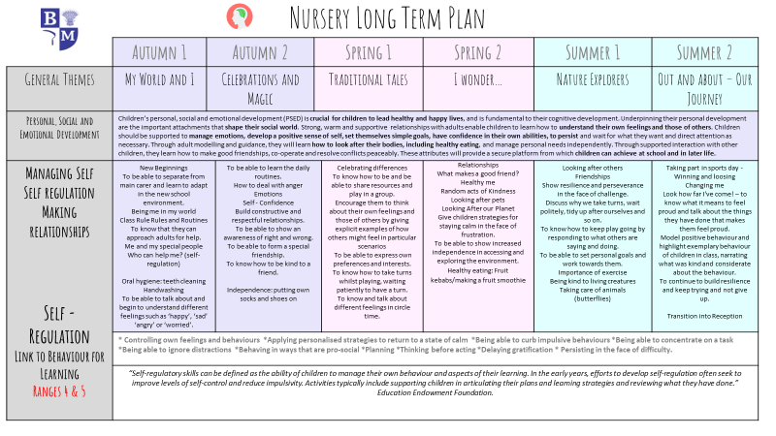

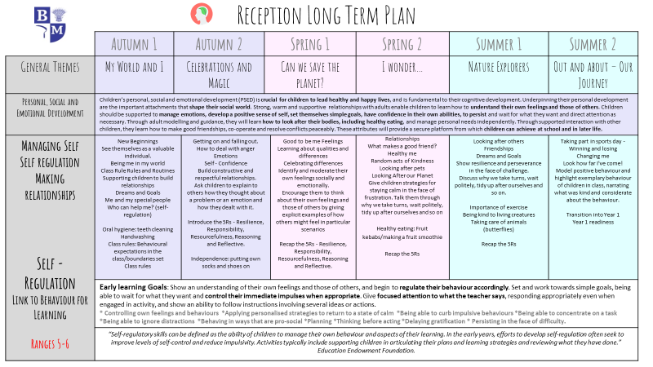

Appendix 2
Mapping of the coverage of the statutory Relationships Education, Relationships and Sex Education (RSE) and Health Education published by the Department for Education.
Numbers relate to the lesson sequence found on the PSHE overviews for each year group.
