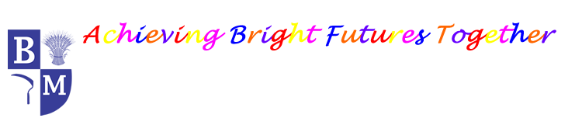
Barley Mow Primary School
PE Overview 2025-2026 V2
 | Autumn Term |  | Spring Term |  | Summer Term
Nursery | Introduction to PE: Unit 1 | Fundamentals: Unit 1  Soft Play | Ball Skills: Little Kickers | Gymnastics: Unit 1 | Ball Skills: Unit 1 | Games: Unit 1
Reception | Introduction to PE: Unit 2 | Fundamentals: Unit 2  Soft Play | Little Movers: Dance  Ball Skills: Little Kickers | Gymnastics: Unit 2 | Ball Skills: Unit 2 | Games: Unit 2
Y1 | Gymnastics | Ball skills | Little Mover: Dance | Target Games | Athletics | Striking and Fielding
Y1 | Fundamentals | Fitness | Invasion Games Football | Invasion Games/ skills | Athletics | Team Building
Y2 | Gymnastics | Ball Skills | Fitness | Little Movers: Dance | Athletics | Striking and Fielding
Y2 | Fundamentals | Dance | Invasion Games Football | Invasion Games/skills | Target Games | Net and Wall  Tennis
Y3 | Gymnastics Coach | Fitness | CDC: Dance | Yoga | Athletics | Rounders
Y3 | Striking and Fielding Cricket | Ball skills | Invasion Games Hockey | Dodgeball | Net and Wall  Tennis | OAA
Y4 | Swimming | Swimming | Swimming | Swimming | Swimming | Cricket
Y4 | Invasion Games Hockey | Invasion Games  Tag Rugby | Gymnastics | CDC: Dance | Athletics | Net and Wall  Tennis
Y5 | Invasion Games Hockey | Dodgeball | Gymnastics | Invasion Games Tag Rugby | Badminton | OAA
Y5 | Net and Wall  Tennis | Yoga | Fitness | CDC: Dance | Athletics | Rounders
Y6 | Gymnastics Coach | Fitness | Invasion Games Hockey | Invasion Games Netball | Cricket | Swimming
Y6 | Basketball | Handball | CDC: Dance | Badminton | Athletics | Rounders

